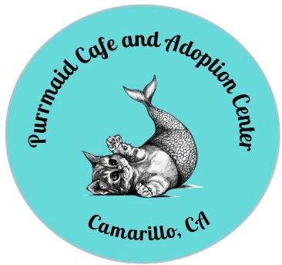

Volunteer Application Form

Thank you for your interest in volunteering with the Purrmaid Café and Adoption Center. We are a non-profit, all-volunteer organization providing care and shelter to homeless cats with the ultimate goal of finding permanent, loving homes for each of them.
Volunteers are needed every day, 365 days a year and are vital to the success of our organization. Please complete this application and email it to purrmaidcatcafe@gmail.com. After your application is reviewed, a Purrmaid representative will contact you with further information.

Name___________________________________________________________Date__________

Address_______________________________________________________________________

City___________________________________State________________Zip_________________

Best phone number to contact you_________________________________________________

Email_________________________________________________________________________

Volunteer Requirements: Volunteers must at least 16 years old. Duties include cleaning cat rooms, changing litter, feeding, grooming etc. Previous experience with cats is required. Please complete the following information.
- Why would you like to volunteer with us?

- What days and hours would you be available?

- Describe your experience working with cats.

- Please tell us of any special skills, training, or experience you have.

- Is this volunteer request for school community service? If so, what is the name of the school?

- Do you have any physical limitations that would prevent you from lifting up to 30 lbs, kneeling down, or lifting your arms above your head? (We want to make sure that we do not ask you to do something you cannot do).

Please check other volunteer opportunities you are interested in:
____Baking Goods - Bakers are always needed to provide goodies for our cafe.
____Special Events - Assist with setting up or work a few hours at the event, usually in the evening.
____Photographers - Purrmaid is looking for people with photography skills. Videos are also needed.
____Supplies/Donations Pick-up - Purrmaid sometimes needs people to pick up donations and supplies for the shelter.
____Handyperson - A general fix-it person is always needed.
____Other:____________________________________________________________________

THANK YOU SO MUCH FOR WANTING TO VOLUNTEER!

