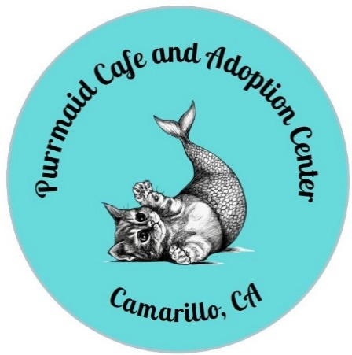
PURRMAID CAFÉ AND ADOPTION CENTER
A 501[c][3] Non-profit Corporation
5800 Santa Rosa Road, Suite 142
Camarillo, CA 93012
(805) 419-6116

ADOPTION APPLICATION
Each Adoption Application is reviewed for suitability prior to placement. We reserve the right to deny anyone the adoption of a cat. All placements are at the discretion of Purmaid Café and Adoption Center. Applicants must be 18 years of age or older. Any application that is incomplete or that contains false information will not be considered. By submitting this application, you give permission to Purrmaid Café and Adoption Center to investigate and confirm the information provided. If your application is approved, Purrmaid will request a home check. You will also need to sign an Adoption Contract to finalize the adoption.

Name__________________________________________ CA Driver’s License_______________
Address____________________________ City_________________ State______ Zip_________
Email________________________________ Preferred Phone for Contact__________________
Name of Cat you are applying for____________________________________________________
Number of Adults in household_____ Number of Children in household______ Ages___________
Who will be primarily responsible for the cat’s care? ____________________________________
Why do you want to adopt a cat? ___________________________________________________
Have you ever adopted a cat before? If so, from whom? _________________________________
List pets in current household:
Dog/Cat | Breed | Name | Age | M/F | Altered? | How long owned?

Are there restrictions as to the number of pets at your residence? _________________________
Do you live in an apartment, condo, or single-family home? ______________________________
If you rent, name of landlord and phone number _______________________________________
Will the cat be indoor only? ___________ Indoor/Outdoor? __________
Have you had a cat declawed? Purrmaid does NOT endorse claw removal ___________________
What will you do if the cat develops behavior problems? _________________________________
Are you aware that cats require yearly examinations and vaccinations? _____________________
Do you understand that this cat could live up to 20 years and will be dependent on you for love, food, shelter, health, and veterinary care? Are you willing to take on this commitment? ________
Should you be unable to care for the cat, who have you designated to care for it?
Name_____________________________________ Phone______________________________
Do you have a vet? ______ If so, name of vet ____________________ Phone ________________

By signing this form, you understand that this cat adoption is “as is.” Although we endeavor to assure the cat’s current health as good and will inform you of any known health or behavioral issues, we cannot guarantee what issues may arise nor what potential health problems may occur.
If for any reason this cat does not work out in you home, you are obligated to return the cat to Purrmaid Café and Adoption Center. Your adoption fee ($150.00) will not be refunded.
By signing below, you certify that all information on the application is true. You understand that any false information may void this application.

Name_______________________ Signature ___________________________ Date__________

